MASSAGE SERVICES

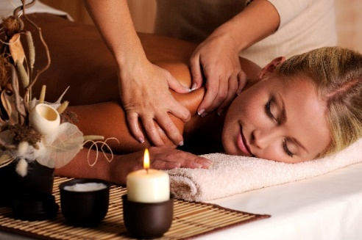

Swedish Massage
Enjoy a traditional Swedish massage to soothe your body and comfort your soul. Choose light, moderate, or deep pressure.

50 minutes $100
80 minutes $140

Hot Stone Therapy
Experience the warming sensation from our hot stones as they are smoothed over aching muscles.
Basalt Stones (Deep pressure and heat)

50 minutes $130
80 minutes $160

Himalayan Salt Stones (Warm salt crystal stones to sooth tension and stress while their natural salt properties gently exfoliate the skin)

50 minutes $140
80 minutes $170

Prenatal Massage
This luxurious massage helps decrease stress and increase circulation while you’re expecting. Expectant mothers must be past their first trimester.
50 minutes $100

Spa Packages Fit for Royalty

Fit for Two
*Priced per couple

Romance Escape Package $330*
80- minute dual hot stone, deep tissue massage, a scrub for your back, ended with a glass of champagne.

Royalty Package $330*
60-minute hot stone massage | 20-minute reflexology

Couples Royalty Plus Package $400*
80-minute hot stone massage | 10-minute reflexology
10-minute scalp massage

Self-Care

Diamond Package $175
50-minute package that includes the Lewiston Retreat and the Remedy
Pearl Package $125
50-minute package that includes a 25-minute massage on an area of your choice, followed by a mini mud mask treatment for your face, and a hand and foot rejuvenating sugar scrub treatment.
Spend the Day $325
This is a head-to-toe service that will have you just focusing on yourself. Relax and enjoy a full body,
Himalayan hot stone massage and a full body mud wrap
coupled with a deep reflexology treatment. (2 hours)

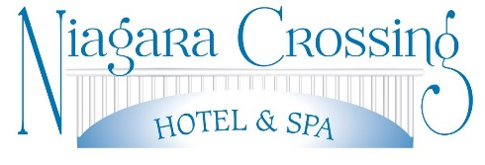
100 Center Street, Lewiston, NY 14092
716.754.9070
Fd@niagaracrossinghotelandspa.com
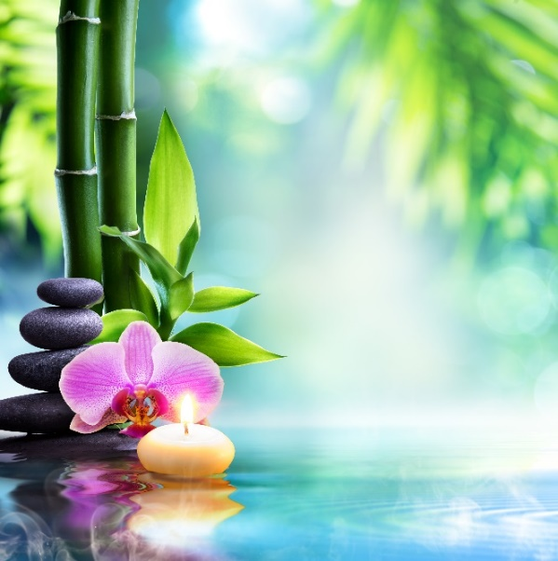

Hours of Operation
All services are by appointment only.

Appointment Etiquette
Should the need arise to cancel or reschedule reservations the cancellation fees are as follows:
You may cancel your appointment without charge any time before the close of the business day preceding your appointment.
Same day cancellation fee is the full-service cost.
All no-show reservations will be charged full-service value.

Add On’s
The Remedy $60
This is a scrub applied to the feet, followed by a reflexology treatment to work out those tender areas and ending with a relaxing moisturizing massage. (30 minutes)

Essential Oil $10
Peppermint, Eucalyptus, Lemon, and Lavender
Reflexology $50
Hand and foot massage (30 minutes)
Lamarca Prosecco 187ml $6
Fruit and Cheese Platter $25
($25 for every 2 people)

Seasonal Specials
Velvet Coffee Scrub $130
Let your body dive into the aroma of coffee beans while the scrub gently exfoliates your skin, followed by a moisturizing massage. This treatment aids in reducing cellulite, while tightening skin, and is anti-aging. (60 minutes)
Pumkin Pie Scrub $125
Give thanks to your skin and indulge yourself with a pumpkin pie scented scrub to help exfoliate and leave your skin feeling smooth and sweet, followed by a full body moisturizing massage. (60 minutes)

BODY TREATMENTS

Peppermint Mud Wrap $130
Peppermint sticks scented mud wrap followed by a 30-minute massage on an area of your choice. (60 minutes)

Seaweed Mud Wrap $125
Detoxify your body with our all natural, vitamin enriched clay, coupled with mint essential oils to stimulate your senses and skin, followed by a moisturizing body massage. (50 minutes)

Sea Salt Scrub $125
Experience full-body exfoliation with this seaweed and scent infused sea salt scrub, followed by a deep hydration massage. (50 minutes)
Lavender Moon Glow $100
Experience a full body exfoliation with a Himalayan lavender infused salt scrub. Rejuvenate your skin back to health and your body back to tranquility. End the treatment with a full body moisturizing massage that includes a lavender coconut cream to sooth and nourish your skin. (50 minutes)
Lewiston Retreat $130
This is a 3-step whole body journey which will restore your natural flow of energy and balance your body’s natural bio rhythms. This treatment includes lymphatic dry brushing, scalp massage, full body massage, ending with a lemon essential oil foot treatment, and serenity and relaxation to melt away all your daily stress. (50 minutes)

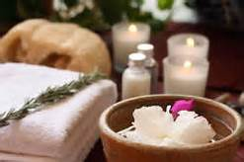

Relaxation
R & R Package $230
Peppermint sticks sugar scrub followed by a full body hot stone massage. (80 minutes)
Treat Your Feet $80
This is a sugar cookie foot scrub with added hot stones for the calves, followed by a relaxing foot massage. (30 minutes)
Bride To Be $400
Unwind before or after your big day! Enjoy this head-to-toe package that includes a mini mud mask treatment for your face, a full body hot stone massage, a full body scrub with a scrub of your choice including a hand and foot rejuvenating scrub treatment, finished off with relaxing reflexology and a glass of champagne. (3 hours)

